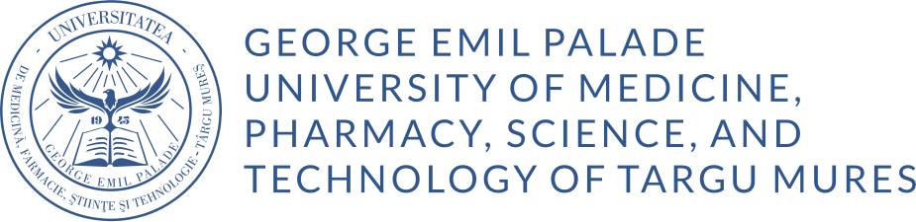
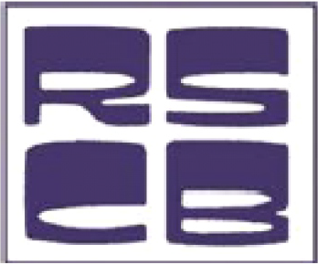
41ST ANNUAL SCIENTIFIC SESSION
of the
ROMANIAN SOCIETY FOR CELL BIOLOGY

International Conference
Under the auspices of the Romanian Academy
and the Academy of Medical Sciences

December 11-13, 2024
Târgu Mureș

REGISTRATION FORM

Name:
First name:
Gender:
Phone number:
E-mail address:

Country:

Correspondence address:

Member of the Romanian Society for Cell Biology? [Yes/ No]:

CUIM / Physician Unique Identification Code (if not available, please type 000):

Medical specialty:

Professional degree:

Affiliation:

Participation type:
in presence
online

Active participation [Yes/ No]:
- oral presentation:
- poster presentation:

Participation Fees:
- SRBC members: 300 RON
- Non-SRBC members: 350 RON
- Online participation: 250 RON
- Accompanying persons: 200 RON
- PhD students and master's students: 150 RON
- Students: 50 RON (provided they attend full-time courses and submit a poster presentation)
- Abstract publication fee: 30 RON/abstract

